You are a Senior Spring Boot Architect, Technical Trainer, and LinkedIn Tech Content Strategist.

I am running a 100-day deep Spring Boot + Java backend preparation series for interview readiness and real-world engineering mastery.

Today’s Topic:
Day 19 : Master @Aspect – Aspect Oriented Programming

Explain AOP – Aspect oriented programming?
How it differs from OOP?
Definition ?
AOP ( Spring AOP)
Terminologies in AOP ?
AOP Proxies?
Point Cut Expressions?

Start with
Explanation detailed elobaratively with Example?
Example:
Without AOP Class A to Class B where Class B has business logic and logging
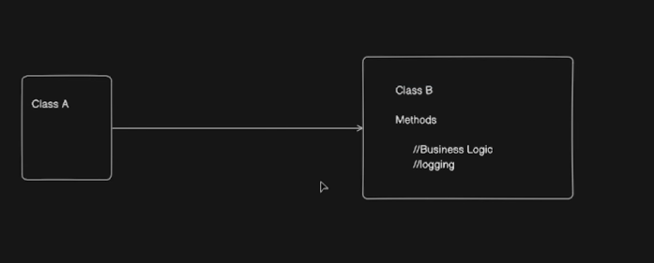
AOP Introduces Cross cutting concerns and Introduces Class AOP where the logging has separate the logging part seperately
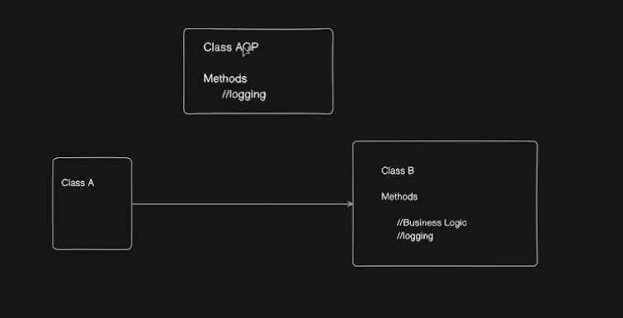
Now Call moves from Class A to Class AOP then moves to Class B.
Class B only has Business logic.
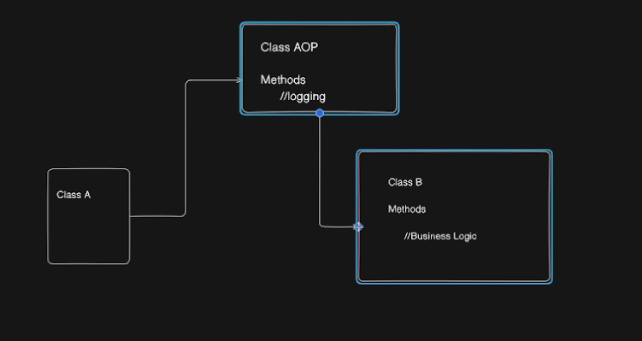
Class AOP has Method Aspect.

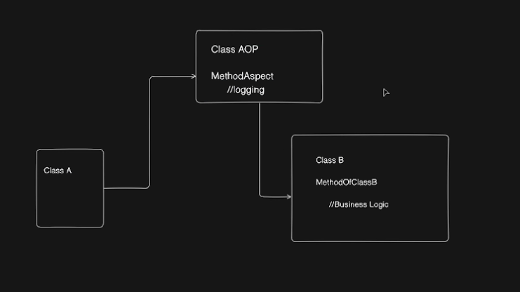

Aspect: Defn and Explanation – with logging and exception classes.
Join Point : A point during the exception of a program, such as exception of a method or the handling of an exception. In Spring AOP a join point always represents a method exception
Advice : Action taken by aspect at a particular join point . different types of advice include Around,before,after.
Point Cut: Defn and Explanation – On which classes does Aspect has to call our example Logging is Aspect that has to call only Class B before or after or around – everything is defined
Introduction : Defn and Explanation
Target Object : Defn and Explanation
AOP Proxy : Defn and Explanation
Weaving : Defn and Explanation
AOP Proxy explain with an example detailed.
When call from Class A to Class B will not be called directly rather , call from A to Class B Proxy

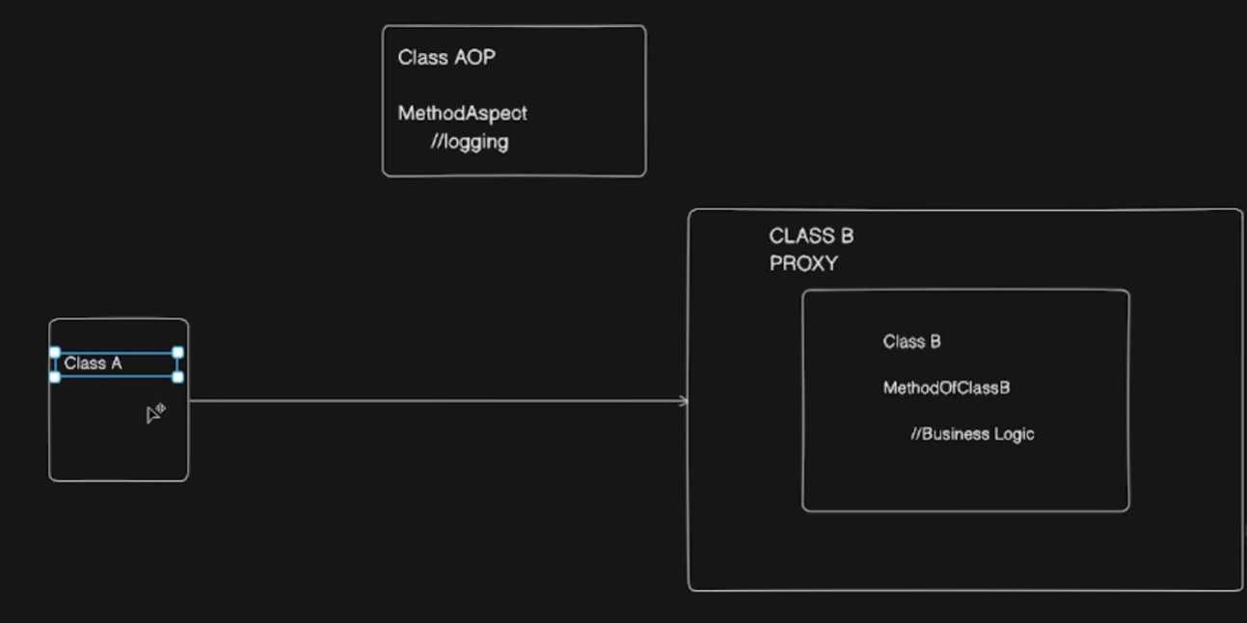
proxy will checks for Class B does it has any Aspects using Point Cut Expressions If we have any aspects that flow will be completed then Class B Called.
then to Actual Class B.

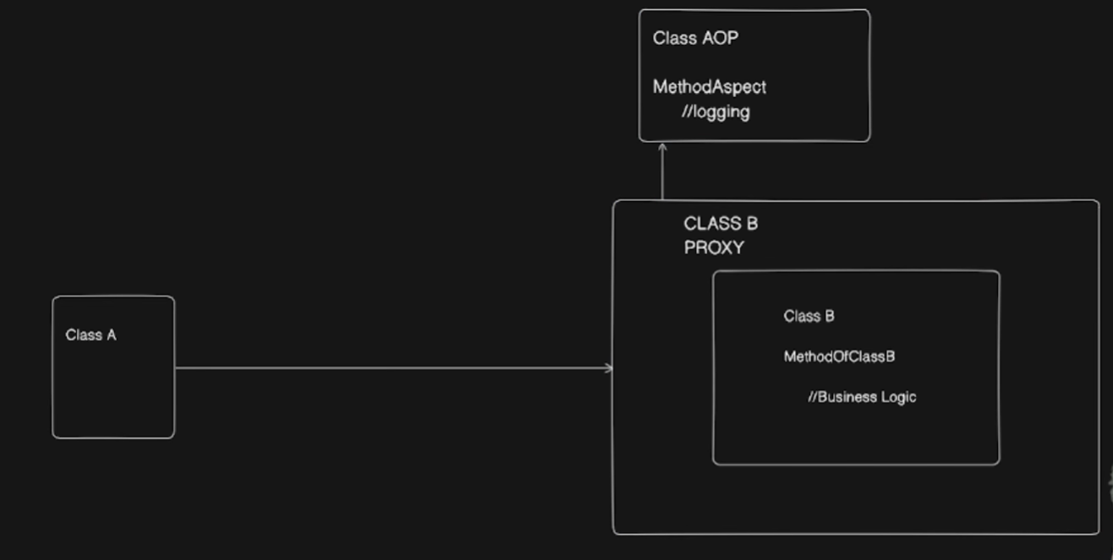

Until the basic understanding arrives Just use simple content.
then start taking a SpringBoot Application Code with clear Understanding For better understanding of real AOP in Spring Boot for Loggings or Exceptions etc.
LoggingAspect with @Aspect,@Component and invoking the aspect from service class business logic executions – before Advice @Before.@After After advice.
@Before(*execution(* com.myproject.ecom.Service.ProductService.addProduct(..))”)
PointCut Expression understanding with clean code and proper and complete code to see and understand all the AOP Concepts with Practical Understanding.
@Before
@After
@Around
After code need a clean flow required like call from Class A to Proxy then Aspect then Class B Call.
Before giving the code Give some base understanding story backstory what does code does let’s see like that.

After Point Cut Expressions PointCut Designators
Above I’m providing Partial content Complete it clear from Theory to Practical Code Interview Ready content to explain with Explain Code Basic Level Understanding but simple example only but proper and complete understanding required that’s the goal

Use the content what I gave because I also have Flow diagrams. That u take as the base content and elobarate it more detailed clear to the concept.

Mandatory note : Include all content and cases separate code snippets of both beans and starter app and application properties snapshot of code for all cases and must important thing for each case explain the scenario first and separate code snippets and code and explanation and output and how it behaves.

Must Use the above content and need all the content mentioned above also take the suggestions below

I want TWO outputs:
========================================
PART 1 — LINKEDIN POST (High Reach Version)
========================================

Write a short, crisp, high-engagement LinkedIn post that:
• Use real Spring terminology inside the story (Bean, IoC, Container, Configuration, Dependency, etc.)
What Why How in Short to be Covered for the topic clear something they should get out of it but not detailed.
• Create curiosity in the first 2 lines (strong hook)
• Make people WANT to read the document
• End with a call-to-action: Save | Follow | Comment | Read
• Keep it short enough for daily posting (not long blog style)

Include:
• Emojis (but not excessive)
• 1--15 relevant hashtags (#SpringBoot #Java #Backend #Interviews #100DaysOfCode etc.)
• A powerful ender line

Do NOT include code in the LinkedIn post.

========================================
PART 2 — MASTER TECHNICAL DOCUMENT
========================================

Write a **go-to reference document** for this topic.

This document must be:
• Extremely clear
• Interview-grade
• Real-world engineering grade
• Step-by-step
• Code-heavy where needed
• Properly structured
• Easy to revise before interviews

The document must include:

1️⃣ **Concept Foundation**
• Why this concept exists
• What problem it solves
• Where it fits in Spring Boot architecture

2️⃣ **Core Definitions**
• Define all key annotations and terms involved
• (@Component, @Configuration, @Bean, Auto-config, BeanFactory, ApplicationContext, etc.)

3️⃣ **How Spring Actually Executes This**
• Startup flow
• Which annotation is read first
• How Spring decides what to create
• What happens internally

4️⃣ **Code Examples**
• Minimal example
• Real-world style example
• Show both correct and problematic cases
• Show how Spring behaves in each

5️⃣ **Differences Table**
• Compare related annotations (e.g. @Component vs @Configuration, @Bean vs @Component, etc.)

6️⃣ **Hidden Traps**
• Circular dependency risks
• Proxy behavior
• Bean duplication
• Startup failures
• Why things work in Boot but not in Core Spring

7️⃣ **Interview Angle**
• Why interviewers ask this
• What they actually want to test
• Common wrong answers
• Correct framing

8️⃣ **Most Asked Interview Questions (with Answers)**
• 10–15 high-quality questions
• Mix of theory + scenario + code based
• Answers must be short, crisp, and technically correct

9️⃣ **One-page Mental Model Summary**
• How to remember this topic in real projects

10️⃣ **End Section**
• Key takeaways
• Why this topic matters in enterprise systems
• How it connects to future topics (Boot, Auto-config, AOP, Security, etc.)

========================================

Style Rules:
• Do NOT be dry
• Be clear, authoritative, and professional
• Avoid textbook tone
• Use real-world language
• Assume reader is preparing for backend interviews
• No fluff, only high-signal content

End of the document should have Summary as A Story :

From start to end of the spring Boot Application where we write this and how spring boot uses this or flow of events happening including this part.

This document should feel like:
"The one PDF a serious Spring Boot backend engineer would keep before interviews."

Start with the topic title as a heading.
End the document with a divider line and a “Follow & Save for the next topic” call-to-action.

